**CSS 534  
Program 4: Parallelizing Shortest-Path Search, using a BFS approach on Spark**

Name: Yifeng Zhang

Date: Nov 24, 2019

Contents

1. Implementation Summary ………………………………………………………………….. 2

2. Source code …………………………………………………………………………………. 2

3. Execution Output ……………………………………………………………………………. 3

3.1 Compile and run my code …………………………………………………………. 3

3.2 output with source and destination vertices 0 and 1500, 0 and 2999 …………….... 3

3.3 Comparison of performance ………………………………………………………. 3

4. Discussions …………………………………………………………………………………. 4

4.1 Pros and cons of program 4’s original algorithm …………………………………. 4

* 1. Execution performance ……………………………………………..…………….... 4
  2. my improvement algorithm ………………………………………………………… 5

5. Lab …………………………………………………………………………………………… 5

* 1. Lab 4A …………………………………………..…………………………………. 6
  2. Lab 4B …………………………………………..…………………………………. 9

*Note: please read readme.txt to know the files detain in my submission folder*

**1. Implementation Summary**

In this assignment, I implement breadth first search (BFS) based shortest path search using parallelizing technique – Spark. I followed the algorithm and requirements in professor’s assignment4.

First, read the whole graph information from file (graph.txt created by GraphGen.java with any number of vertices) and get the from source and destination parameter from **args**. Using data class as vertex attributes. In data class we add parameter **prev** to record the previous distance so that we can compare the mapped value and get new shortest distance and active the vertex or keep previous distance during the reduce stage.

Second, create JavaPairRDD by calling a transformation, **lines.mapToPair**. Set all the vertex’s distance **as Integer.MAX_VALUE**, prev as **Integer.MAX_VALUE** and status as **INACTIVE** except the source data with distance as 0, prev as 0 and status as **ACTIVE**.

Third, start a while loop to compute the shortest distance in 3 steps when there are any “ACTIVE” vertices (count the vertices’ status to return true or false). first step to map the data using **flatMapToPair** method. Add the current vertex into list. If the vertex is **ACTIVE**, create all new neighbors’ data only with the update distance and invalid prev(distance) and **INACTIVE** status. put them into list. Second part is the reduce function using **reduceByKey**. For each key (vertexID), we reduce their distance and prev. Third part to check if the vertex updates the current distance with newer shortest distance. If it is, set it **ACTIVE**.

Fourth, after down the while loop (map and reduce), go to find the shortest distance using lookup to get data and print the shortest distance out.

For verifying my implement is correct, I use **collect**() method to get all list of data and print out the information with for loop in each map-reduce loop.

**2. Source code**

The source code (ShortestPath.java) is under src folder in my submission report. I copied the professor’s Data.java. Use sp_compile.sh to compile my code and using spark-submit to run my code.

**3. Execution Output**

**3.1 Compile and run my code**

1. Using sp_compile to complie my java code and get ShortestPath.jar;

2. Run my code on different number of computing nodes with different average cores per node. Change the slaves file to give different number of computing node(1-4), and then run code with the following command using different **total-executor-cores ?**:

**Spark-submit --class ShortestPath --master spark://cssmpi1:58350 --executor- memory 1G --total-executor-cores 1 ShortestPath.jar graph.txt 0 1500 > output**

**3.2 output with source and destination vertices 0 and 1500, 0 and 2999:**

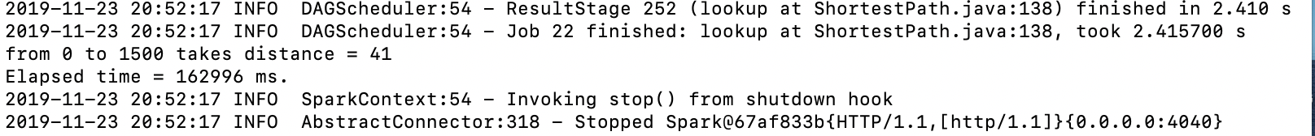







I used **collect**() method to get all list of data and print out the information with for loop in each map-reduce loop. I can track the shortest distance for vertex-1500 changed through the computing: **Integer.MAX_value** - > **90** -> **67** -> **57** -> **46** -> **41**.

**3.3 Comparison of performance**

Compare the performance of the 12 different executions of your ShortestPath program, using a graph of 3000 vertices. The source and destination vertices should be 0 and 1500 respectively. Those time may affect by data shuffle in memory. The best performance improvement is 2.112.

Note: I got different output elapsed time during the different time. The first 9 data from the continuous time period. Since the Spark down for a few hours, I tested last 3 data after recovery of Spark. All my output files in the output folder.

|  |  |  |  |  |
| --- | --- | --- | --- | --- |
| #Computing nodes | Ave # cores per node | Total # cores | Elapsed time (millisecond) | Performance improvement |
| 1 | 1 | 1 | 320278 | 1 |
| 1 | 2 | 2 | 347512 | 0.922 |
| 1 | 3 | 3 | 371589 | 0.862 |
| 2 | 1 | 2 | 159174 | 2.012 |
| 2 | 2 | 4 | 153504 | 2.086 |
| 2 | 3 | 6 | 154223 | 2.077 |
| 3 | 1 | 3 | 164339 | 1.949 |
| 3 | 2 | 6 | 151622 | 2.112 |
| 3 | 3 | 9 | 153280 | 2.089 |
| 4 | 1 | 4 | 153509 | 2.086 |
| 4 | 2 | 8 | 155150 | 2.064 |
| 4 | 3 | 12 | 153276 | 2.090 |

**4. Discussions**

**4.1 Pros and cons of program 4’s original algorithm**

**Pros**: The code is simple. First read the data from input file line by line and create **JavaPairRDD**; Second, in **flatMapToPair** function, create all new distance for an active vertex’s neighbors; Third, in **reduceByKey** function, create new **JavaPairRDD** with updated shortest distance for all vertices. If use MPI, I need write the code to collect all computing result from workers and send new data to workers after reducing in each loop. It means data exchange and parallel part are already taken cared by Spark.

**Cons:** It’s hard to use. Must use **JavaPairRDD** API method to implement the code, and it is hard to understand. It’s hard to track the data during the computing in each core. It’s hard to debug.

**4.2** **Execution performance**

**Pros:** RDD is the fundamental data structure of Spark. It allows a programmer to perform [in-memory computations](https://goo.gl/nH9sf3) on large clusters in a [fault-tolerant](http://data-flair.training/blogs/apache-spark-streaming-fault-tolerance/) manner.

**Cons:** The execution performance is not improved much with more cores, because shuffling data is very expensive. It uses more memory.

* 1. **my improvement algorithm**

In program 4’s original algorithm, I should reduce all the parameters of data. In original algorithm, I need compare the updated **distance** and **prev** to get **status** for each new Data in map function. I only reduced the **neighbors**, **distance** and **prev** and set the status as default **INACTIVE** without computation. In reduce function, in original algorithm, should check if all the **status** to see if any is ACTIVE, then set the **status** as **ACITVE**. In my improved algorithm, I only compare **distance** and **prev** once for each vertex to update the **status**. The time of mapping and reducing the **status** in original algorithm is n(each vertex) * m(1 < m < n, all updated distance), the worst case is n * n, while in my improved algorithm, the time consumption is n * 1 = n.

My improved algorithm is easy to understand and easy to program. The execution performances are better than original algorithm (by comparing the time elapsed time with professor’s data and mine).

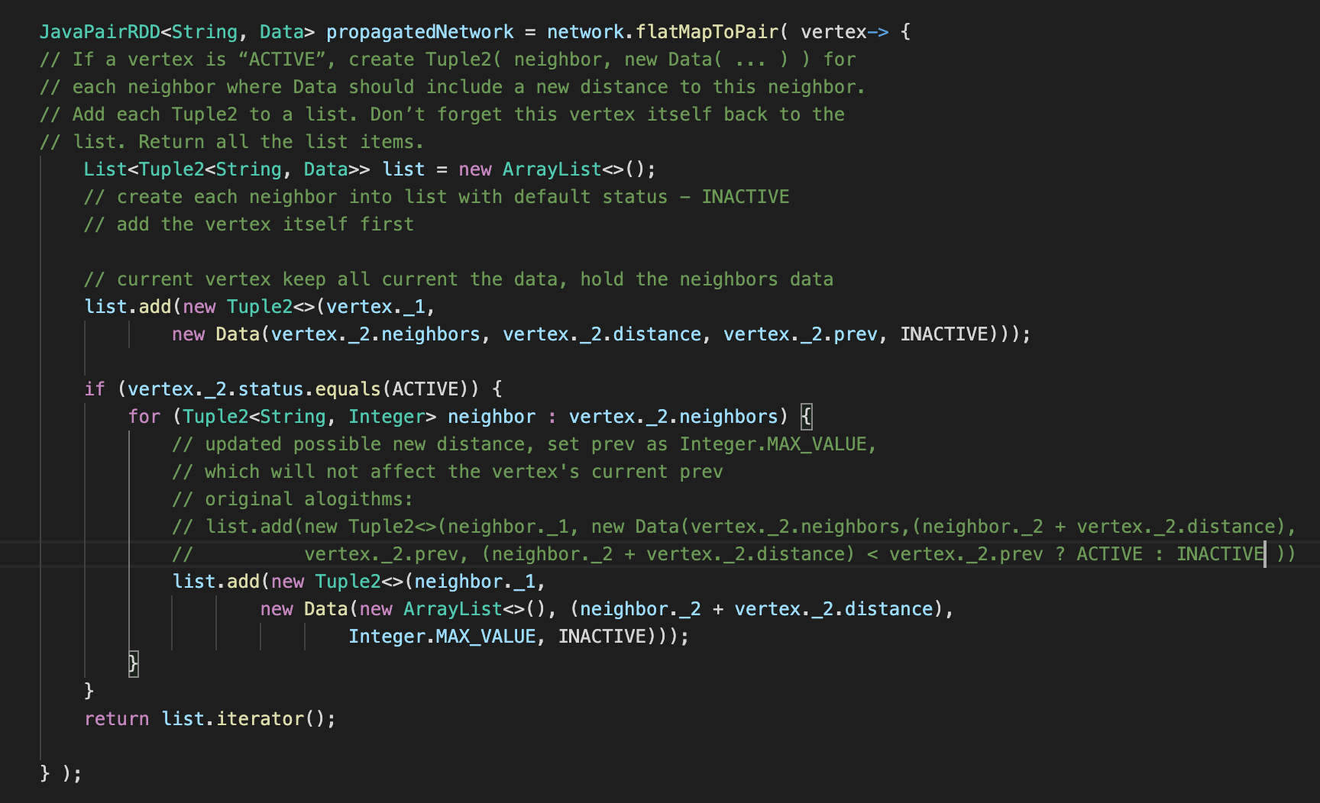

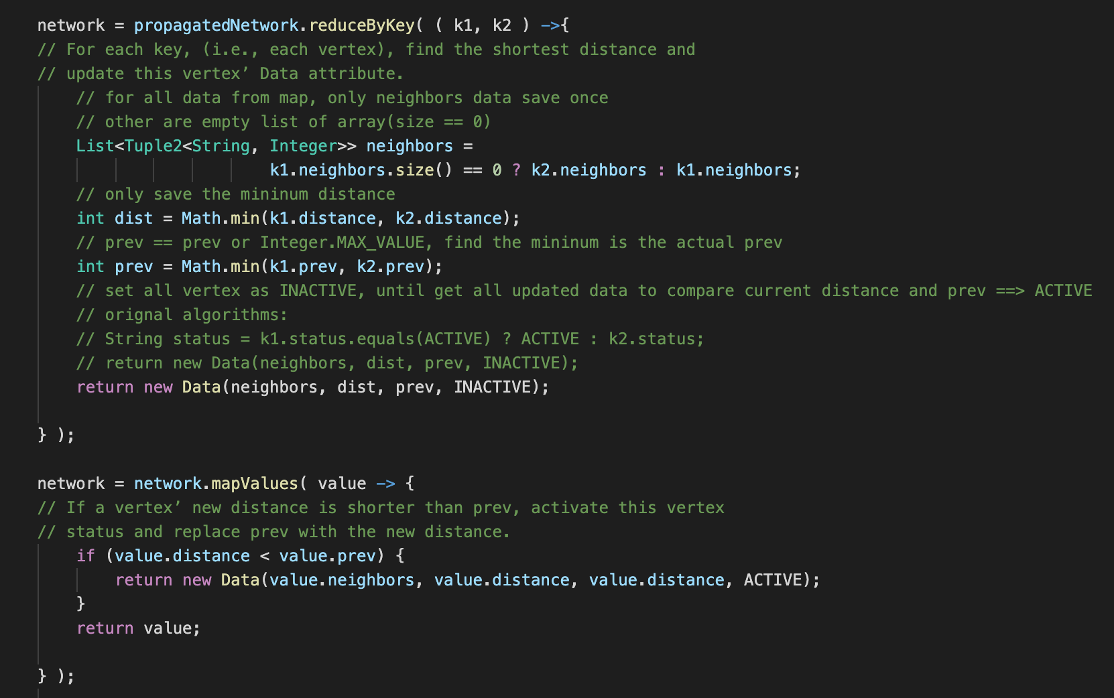

**5. Lab**

**5.1 Lab 4A:** play with pySpark. Copy MyClass.java, compile it, and run it on a single node. The result should same as use python lambda.

#word = 11

max = 5

1. Compile the MyClass.java first:

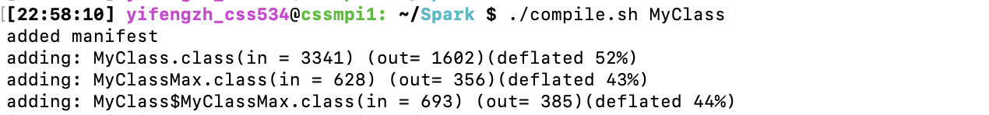

1. The result after running it

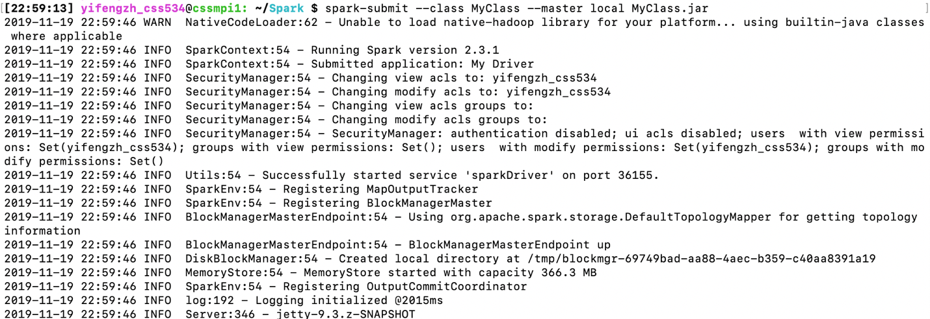

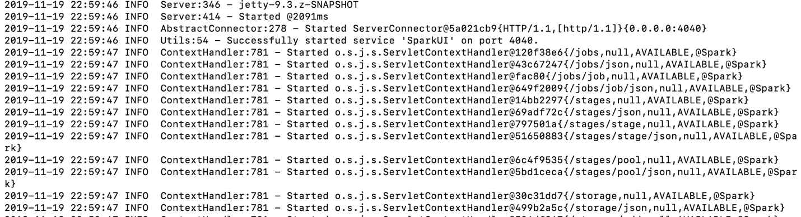

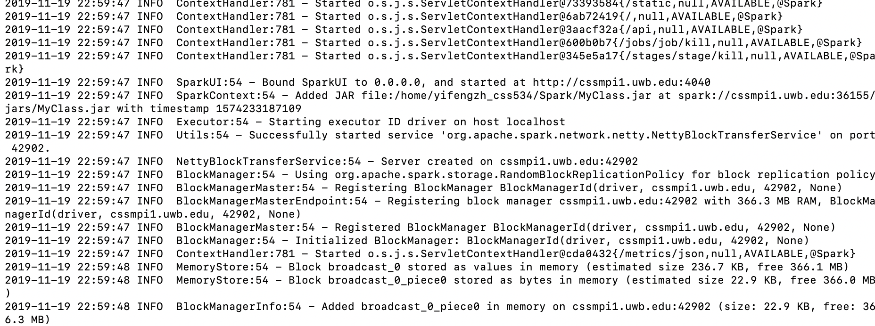

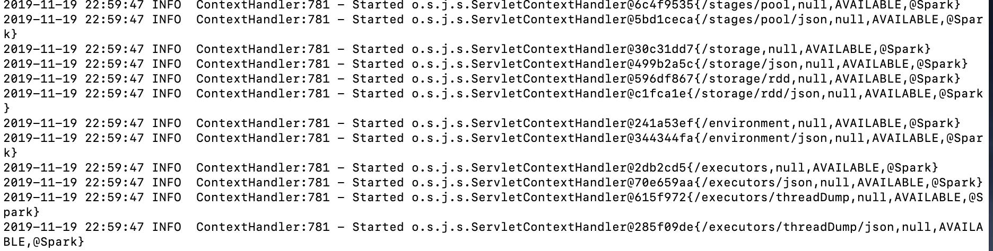

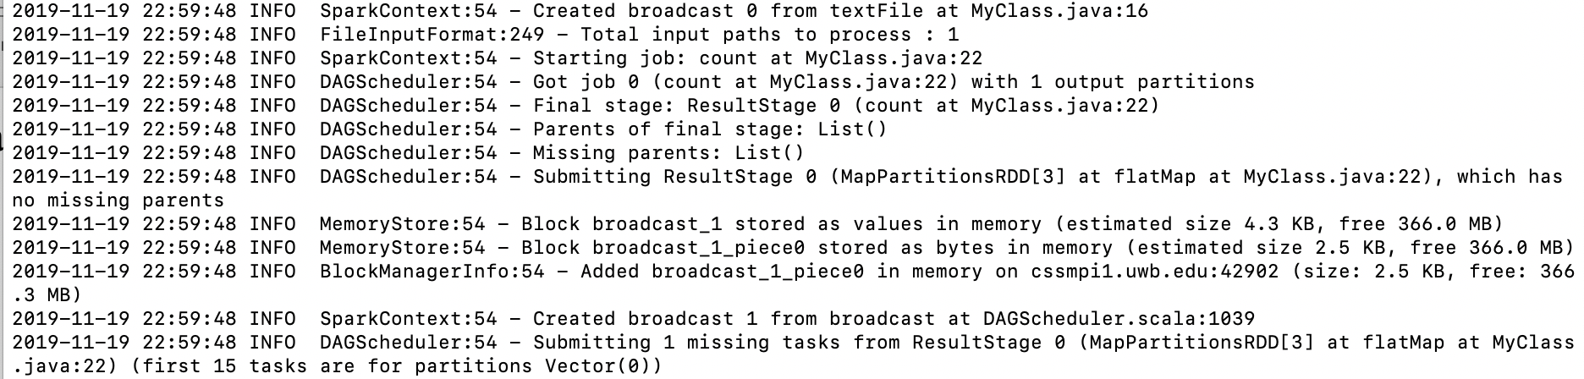

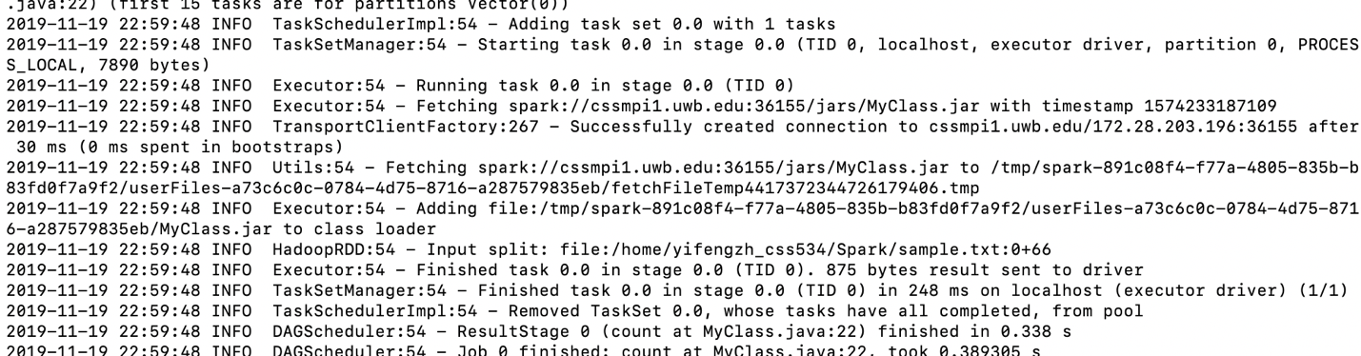

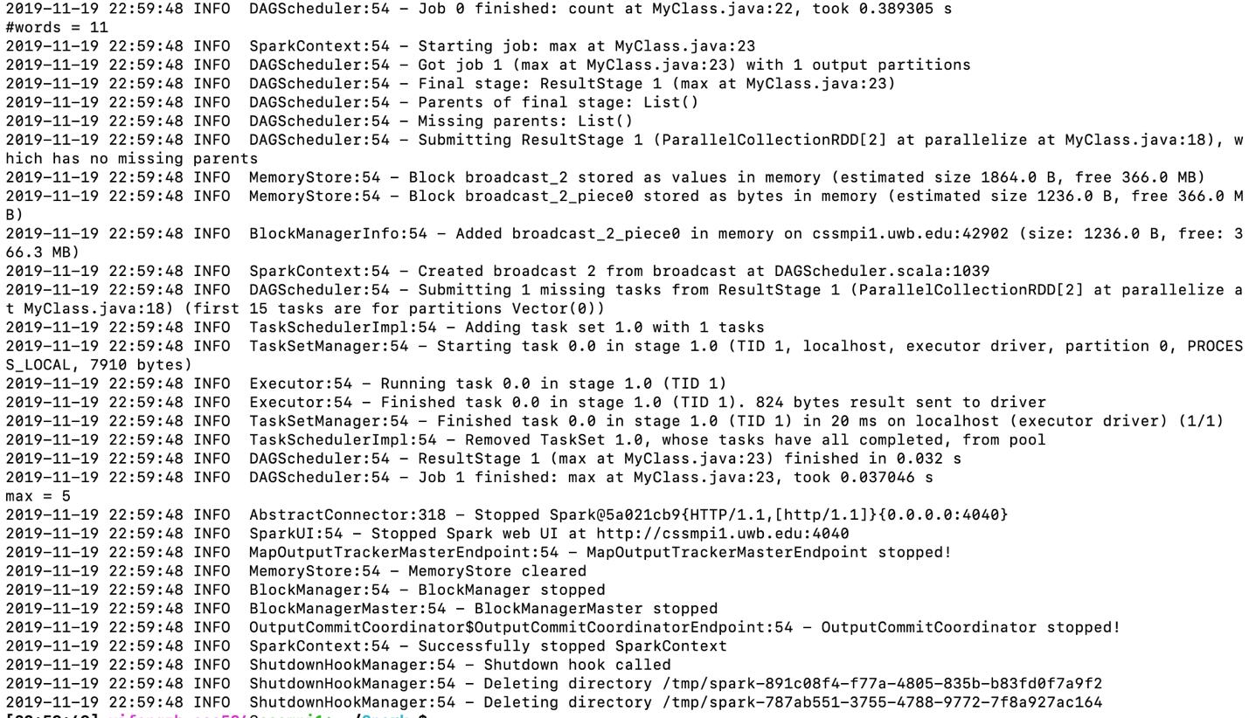



1. The result is same as using python lambda

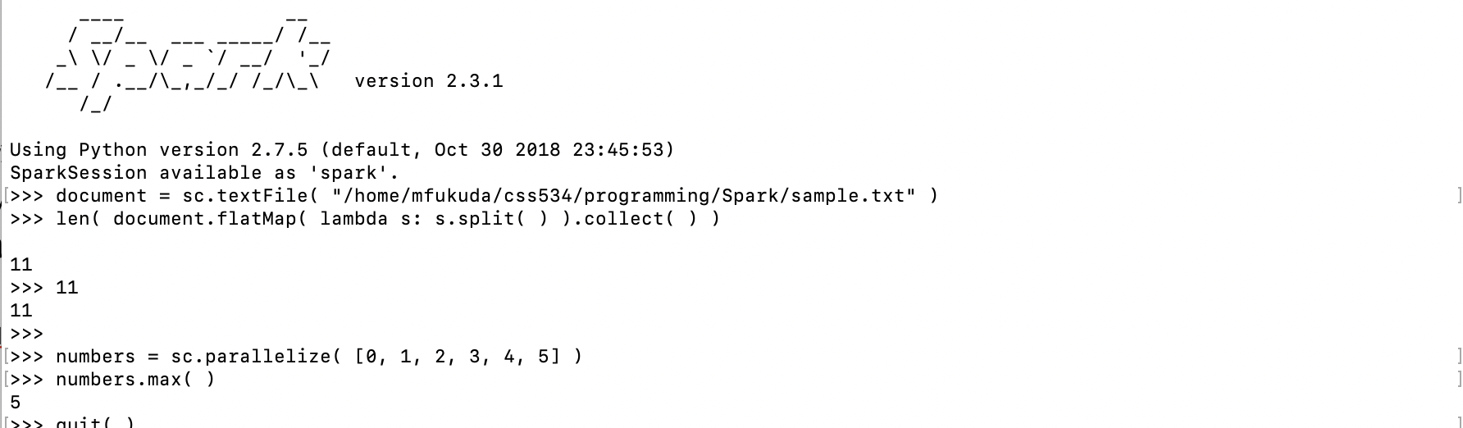



**5.2 Lab4B**

Compile and run JavaWordCountFlatMap on both single machine and over parallel machines.

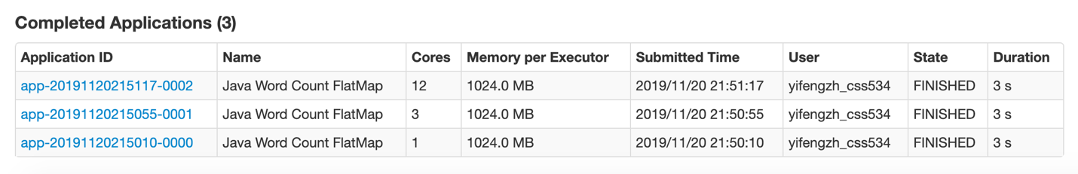

The result is same on single or parallel machines.